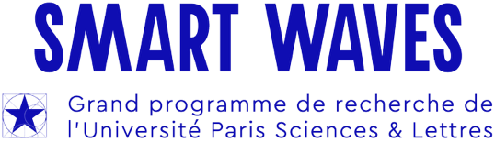

Smart Waves 2026 Call for projects – Equipment

Background to the Smart Waves Major programme
The convergence of diverse scientific cultures within the major "Smart Waves" programme has three concomitant strategic objectives:
- Creation of a dynamic transdisciplinary community specific to PSL on the airwaves,
- Support for disruptive research areas that may encounter development challenges,
- Accelerating innovation.

Thus, Smart Waves is part of the broader mission to establish PSL as a global player in scientific excellence and cutting-edge research on the airwaves.

Call type: Equipment
This program aims to finance all or part of the equipment necessary to carry out a collaborative research topic that involves at least two teams from two different PSL laboratories in approximately equal parts. The amount must be between €20k and €31k.

Submission deadline: June 12, 2026 11:59 pm (Paris time)

Documents must be submitted via the website: https://aap-smartwaves.sciencescall.org/submission/submit

Identity of the request:

Describe in a few lines the purpose of the request

Thematic axis:
Selection of the main thematic axis in which the project is part (and if relevant, a secondary thematic axis)
- Information and complexity
- Communications, analogue computing and wavefront shaping
- Quantitative Imaging
- Innovative materials for waves

Scientific leaders and project partners
There must be at least 2 partners from 2 different laboratories.

PSL Partner A (in charge of recruitment)

Laboratory identity

Name of the PSL unit:

PSL institution:
- Scientific coordinator
  - Affiliated doctoral school:
  - Last name:
  - First name:
  - Email:
  - Phone number:

PSL Partner B
- Laboratory
  - Name of the PSL unit:
  - PSL institution:
- Scientific coordinator
  - Affiliated doctoral school:
  - Last name:
  - First name:
  - Email:
  - Phone number:

Other partners

New collaboration
Is this a new collaboration between 2 or more partners? Yes / No
If not, briefly describe previous collaborations.

Description of the application

Context of the application
Is this request part of a project currently being funded (postdoc or thesis) by "Smart Waves"? Yes / No
If so, which one?

Objectives of the application (1/4 to 1/2 page)

Additional funding
Is this request part of a financing plan for the purchase of expensive equipment? If so, what is the financing plan?

